**HW5 Writeup**

**Prepared By: Woon Kim**

**UNI: wk2371**

**Date: February 27 2022**

[1]

SSE at b_truth = (0.5, 0.75)^T is 12.014552846587636

The smallest loss achieved = 12.000179409325268

The fitted beta = (0.99835, 0.50347)^T

The number of iteration needed to reach this loss = 7

[2]

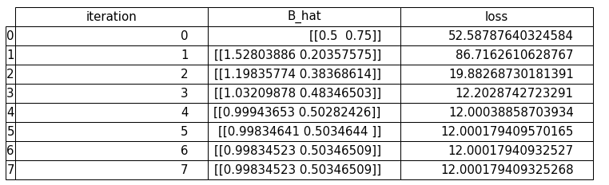

[3]

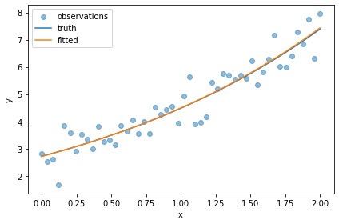

[4]

Estimated RMSE via LOOCV = 0.49019491728469883

[5]

Estimated RMSE via 10-fold CV = 1.9276722948217175